MOMC books suggestion by the Military Inclusion Chair of HCC PTA/PTSA

Jennifer Southerland

Contact: military@hccptaptsa.org

A Paper Hug: by Stephanie Skolmoski

Where do the Tears Go?: by Doris Burd

I am Red, White, and Blue… Are You Feeling it Too?: by Deanna Lynn Cole

Lily Hates Goodbyes: by Jerilyn Marler

When Your Dad Goes to War: Helping Children Cope with Deployment and Beyond: by Maryann Makekau

But … What If?: by Sandra Miller Linhart

My Red Balloon: by Eve Bunting

I Like Where I Am: by Jessica Harper

Alexander Who’s Not (Do You Hear Me? I Mean It!) Going to Move: by Judith Viorst

Great comprehensive list:
http://www.operationwearehere.com/ChildrenBooks.html

All Hands on Deck! Dad's Coming Home!
Author: Julia Maki, Copyright @ 2012

American Hero Books: My Daddy Is a Marine
Author: Alia Reese, Copyright @ 2011
Ages infant-preschool
www.heartstarpress.com

A Paper Hug
Author: Stephanie Skolmoski, Copyright @ 2006

A Year Without Dad
Author: Jodi Brunson, Copyright @ 2003

A Yellow Ribbon for Daddy
Author: Anissa Mersiowsky, Copyright @ 2005
Ages 4-8

Brave Like Me
Author: Barbara Kerley, Copyright @2016
Ages 4-8

But... What If?
Author: Sandra Miller Linhart, Copyright @ 2010

Coming Home
Author: Greg Ruth, Copyright @ 2014
Ages 4-7

Countdown 'til Daddy Gets Home
Author: Kristin Ayyar, Copyright @ 2013
Ages 3-8

Daddy Left with Mr. Army
A child's view of military deployment
Author: Chandelle Walker, Copyright @ 2018
Ages 5-6

Daddy is in the Military
Free book to customize, save and print - www.myownstory.com

Daddy's Boots
Author: Sandra Miller Linhart, Copyright @ 2010
for his job with the military.

Daddy's Deployed
Author: Bridget Platt, Copyright @ 2012
Ages 0-10
http://daddysdeployed.com

Daddy's in Iraq, but I Want Him Back
Author: Carmen R. Hoyt, Copyright @ 2005

Daddy's Submarine
Author: Bethany Patterson, Copyright @ 2019

Dear Baby, I'm Watching Over You
Author: Carol Casey, Copyright @ 2010
Ages 1 and up

Deployment
Author: Santina Rivera, Copyright @ 2010

Deployment: One of Our Pieces is Missing
Author: Julia Cook, Copyright @ 2018

Don't Forget: God Bless our Troops
Author: Dr. Jill Biden, Copyright @ 2012
Ages 5 and up

Father Is Always With Me
Author: Emmanuel Barbosa, Copyright @ 2016
Ages 1-6

Goodnight Marines
Author: David Dixon, Copyright @ 2016
Ages 0-8
A brilliantly illustrated children's book about the culture and traditions

Heart of a Shepherd
Author: Rosanne Parry, Copyright @ 2010
Ages 9-12
Teacher discussion guide available (3rd - 5th grade, 6th - 8th grade)

Hero Dad
Author: Melinda Hardin, Copyright @ 2010
Ages 4-8

Home Again (Board Book)
Author: Dorinda Silver Williams, Copyright @ 2009
Ages 0-3
Available for free at www.militaryonesource.mil

Hug in the Wind
Author: Tim Steiner, Copyright @ 2018

I Am Red, White, & Blue...Are You Feeling it Too?
Author: Deanna Lynn Cole, Copyright @ 2008

If I Were Deployed
Author: Nicole Burch, Copyright @ 2019

I'll Lend You My Daddy
Author: Becky King, Copyright @ 2019
Ages 4-8

I'm a Hero Too! (Daddy version)
Author: Timothy P. Dunnigan, Copyright @ 2011
www.imaherotoo.org

I'm Here for You Now (Board Book)
Free from Military OneSource

I Miss You!
Author: Beth Andrews, Copyright @ 2007
Ages 4-8

Another list:

https://confidentcounselors.com/2017/04/03/9-books-help-military-children/

For teachers, parents and other professional who support military child education: “Seasons of my Military Student”: http://elvaresa.com/book/seasons-military-student/

13 Amazing books to support military children:

https://mrsnavymama.com/13-amazing-books-supporting-military-children/

Preparing for PCS:

https://militaryfamilieslearningnetwork.org/2019/05/09/childrens-books-help-prepare-military-children-for-pcs/

https://unitedthroughreading.org
Download the app and start reading today.
Free books for military families:

https://www.google.com/amp/s/www.military.com/paycheck-chronicles/2011/08/02/free-books-for-military-families/amp

Must have books for Mil kids:
https://www.military.com/spousebuzz/blog/2016/11/11-books-military-children.html/amp

Worry Says What
by Allison Edwards

Today I Feel Silly and Other Moods that Make My Day:
By Jamie Lee Curtis

My Many Colored Days: by Eric Carle

One of our Pieces is Missing: by Julia Cook.

The Color Monster, a popup book of feelings by: Anna Llenas,

When I 'm Feeling Angry: by Trace Moroney

In my Heart- A book of feelings: by Jo Witek.

The Mixed-Up Chameleon: Eric Carle

Leonardo the Terrible Monster: by Mo Willems

Pete the Cat and his Four Groovy Buttons: by Eric Litwin

Have You Filled Your Bucket Today? A Guide to Daily Happiness for Kids: by Carol McCloud

The Brand New Kid: by Katie Couric

Military Family Books:
https://militaryfamilybooks.com/

MCEC Tell Me a Story Event Book List. Check www.militarychild.org for more info on bringing a Tell Me a Story to your organization:

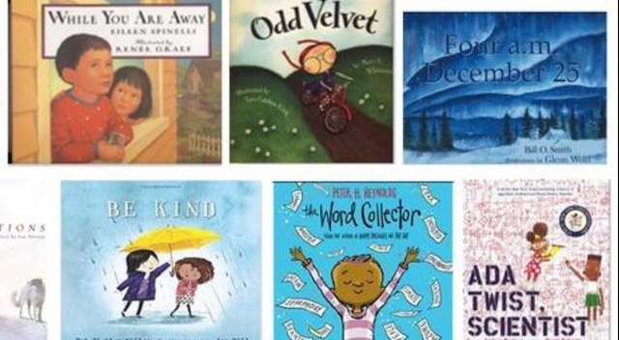

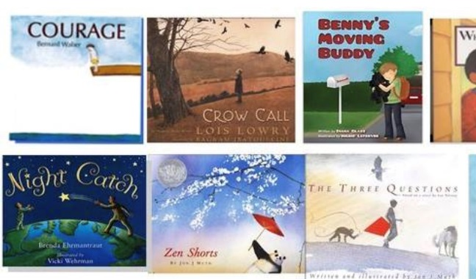
MCEC NTS 2019 reading list:

The Power of Moments by Chip and Dan Heath

How Schools Work by Arne Duncan

Grit: The Power of Passion and Perserverance. By Anne Duckworth

The Leader’s Bookshelf by Adm. Stravridis, USN, ret. and R. Manning Ancell

The Good Neighbor: the Life and Work of Fred Rogers. By Maxwell King

parks by: Peter L. Benson

More MCEC Recommended reference books:

Mindset: by Carol S. Dweck

Special Needs Families in the Military: by Janelle Hill and Don Philpott

Building Resilience in Children and Teens: Giving Kids Roots and Wings: ...by Kenneth R. Ginsburg, MD, MS Ed, FAAP with Martha M Jablow.
1st and 2nd Editions

Serving Military Families, 2nd ed., by: Karen Rose Blaisure, Tara Saatholf-Wellls, Angela Pereira, Shelley MacDermid Wadsworth, Amy Laura Dombro.

Raising Kids To Thrive: by Kenneth R Ginsburg, Ilana Ginsburg and Talia Ginsburg

The Student Leadership Challenge: Five Practices for Becoming an Exemplary Leader: by James Kouzes and Barry Posner

The Five Love Languages of Children:
By Gary Chapman & Ross Campbell, M.D.

Again… the Seasons of My Military Student (website shared above): by authors Amanda Trimillos and Stacy Allsbrook Huisman (also a member of the Randall Middle School PTSA and Military Spouse)

Tip for schools/PTA’s: Host a book club. You can start with: The Seasons of My Military Student. It can help both parents/educators build support strategies. It comes in ebook or hard copy on Amazon. You can share this list with all families on Edsby.

