“Advancing Diversity, Equity and Inclusion in your PTA” is National PTA’s newest diversity, equity and inclusion workshop, facilitated by Sylvia R. Reyna and Frances Frost from National PTA’s Board of Directors and Diversity, Inclusion and Outreach Committee, and Helen Westmoreland, Director of the Center for Family Engagement. This workshop will take a deeper dive into National PTA’s beliefs and definitions for diversity, equity and inclusion; introduce a new self-reflection tool to evaluate your PTA’s DEI journey, and provide you with on-the-ground strategies to make your membership, governance, programming and advocacy more equitable. Throughout the workshop, you will be prompted to reflect on your own PTA’s journey and diversity, equity, and inclusion efforts. Post the completion of this workshop, we hope that you can walk away with actionable items that you will implement in your PTA, and that you are able to make a clear commitment to advancing diversity, equity and inclusion in your PTA.

The workshop is pre-recorded and ideal for a virtual or in-person setting. It was created to be interactive, which will require a facilitator to pause the video, lead group discussions and collect input. If you are using an online meeting platform, such as Zoom, we recommend that you utilize the chat feature and breakout rooms. We have also provided a Workshop Response Form that participants can use to record their answers to the questions throughout the workshop; this form will be live recordings the responses, meaning they will be visible to others.

We have created a facilitator’s guide for a 60-minute workshop that allots the necessary amount time for reflection and discussion. Follow the guide’s instructions to know when to pause and play the video, and when to facilitate discussions with participants.

60 MINUTES (RECOMMENDED)
PAUSE FOR: | FACILITATOR GUIDANCE | VISUAL(S)
:01 Min | [PAUSE AT 00:00]  [WELCOME & INTRODUCTIONS]  - Facilitator: “Welcome to Advancing Diversity, Equity and Inclusion in your PTA. This workshop is pre-recorded, but I will be pausing the video to allow time to respond to the prompted questions throughout the training. Feel free to answer these questions in the chat and in the Workshop Response Form, where you will be able to see what others who have completed the workshop have responded. Each question will be in a different tab along the bottom. I will place the link to the response form in the chat. Please take some time to introduce yourselves, let us know where you are from, and answer ‘why diversity, equity and inclusion matters for your PTA?’”  - Provide participants this link: to answer promoted questions in the Workshop Response Form under the “Welcome” tab  [CLICK PLAY] | Slide 1:  Introduction to Workshop:  Advancing Diversity, Equity and Inclusion in PTA  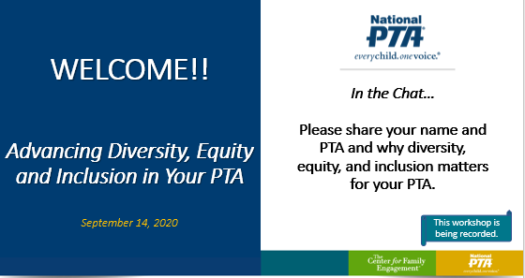  Workshop Response Form:  https://docs.google.com/spreadsheets/d/1ki1Dwnv15cCMaSRgLZlafKxS5aNgInuOjvod7UkD6ns/edit?usp=sharing  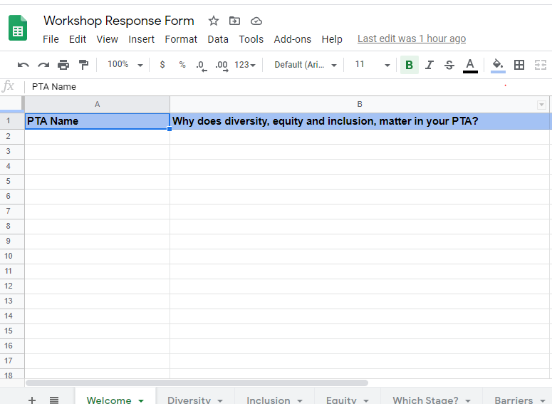
PAUSE FOR: | FACILITATOR GUIDANCE | VISUAL(S)
:01 Min | [PAUSE AT 07:45]  [GUIDE DISCUSSION]  - Prompt participants to answer, “What is one way diversity shows up in PTA?” (Answer in chat or in the Workshop Response Form’s “Diversity” tab )  - If participants are using a chat box, read some of the feedback out loud as it comes in  [CLICK PLAY] | Slide 7:  WE BELIEVE DIVERSITY IS OUR STRENGTH 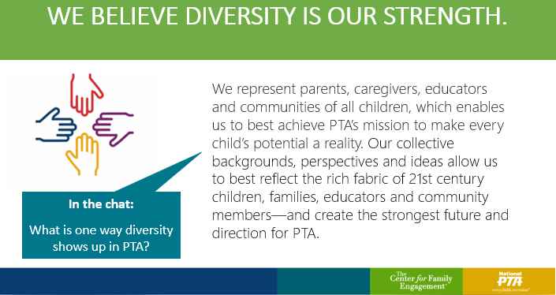  Workshop Response Form:  https://docs.google.com/spreadsheets/d/1ki1Dwnv15cCMaSRgLZlafKxS5aNgInuOjvod7UkD6ns/edit?usp=sharing  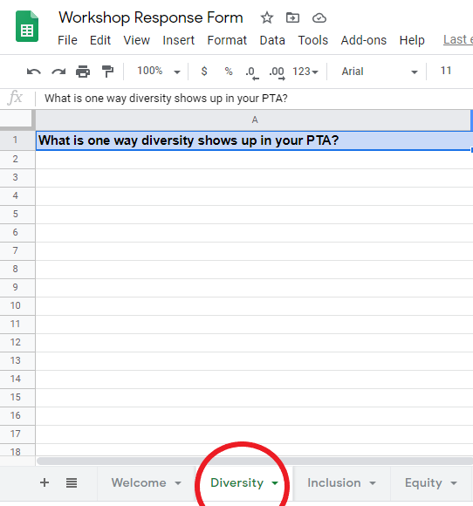

PAUSE FOR: | FACILITATOR GUIDANCE | VISUAL(S)
:01 Min | [PAUSE AT 08:42]  [GUIDE DISCUSSION]  -Prompt participants to answer the question, “What is one way inclusion shows up in your PTA?” (Answer in chat or in the Workshop Response Form’s “Inclusion” tab)  - If participants are using a chat box, read some of the feedback out loud as it comes in  [CLICK PLAY] | Slide 8:  WE BELIEVE COLLABORATION MUST BE INCLUSIVE  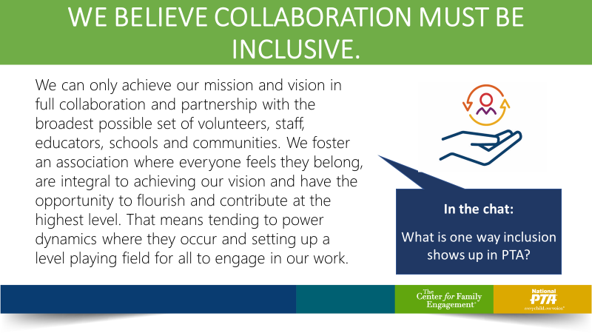  Workshop Response Form:  https://docs.google.com/spreadsheets/d/1ki1Dwnv15cCMaSRgLZlafKxS5aNgInuOjvod7UkD6ns/edit?usp=sharing  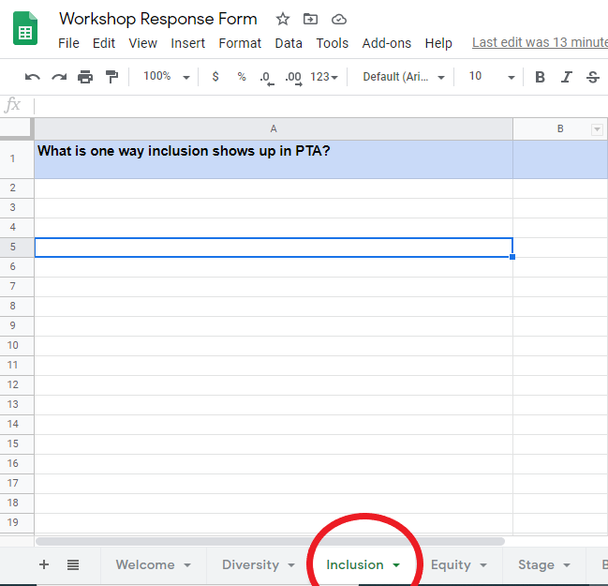

PAUSE FOR: | FACILITATOR GUIDANCE | VISUAL(S)
:01 Min | [PAUSE AT 10:49]  [GUIDE DISCUSSION]  -Prompt participants to answer the question, “What is one way Equity shows up in your PTA?” (Answer in chat or in the Workshop Response Form’s “Equity” tab)  - If participants are using a chat box, read some of the feedback out loud as it comes in  [CLICK PLAY] | Slide 9:  WE BELIEVE EQUITY DRIVES OUR MISSION  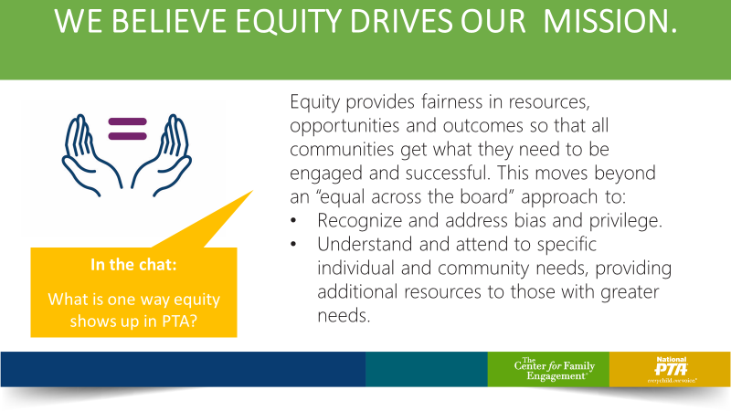  Workshop Response Form:  https://docs.google.com/spreadsheets/d/1ki1Dwnv15cCMaSRgLZlafKxS5aNgInuOjvod7UkD6ns/edit?usp=sharing  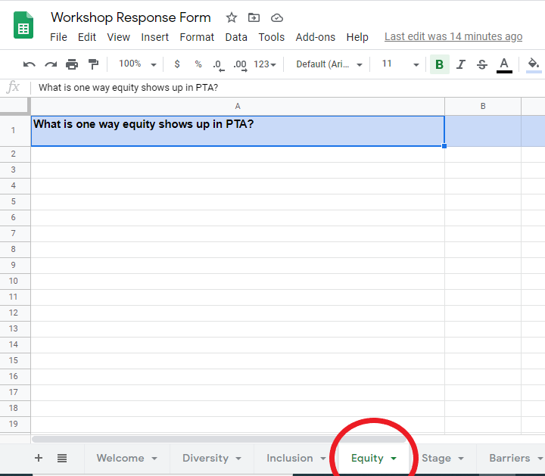

PAUSE FOR: | FACILITATOR GUIDANCE | VISUAL(S)
:01 MIN | [PAUSE AT 14:25]  [GUIDE DISCUSSION]  -Prompt participants to answer the poll question, “What stage reflects your PTA’s DEI efforts?” (Answer on screen or in the Workshop Response Form’s “Stage” tab)  - If participants are answering to a poll on Zoom or another platform, share those results with them  [CLICK PLAY] | Slide 12:  AUDIENCE REFLECTION  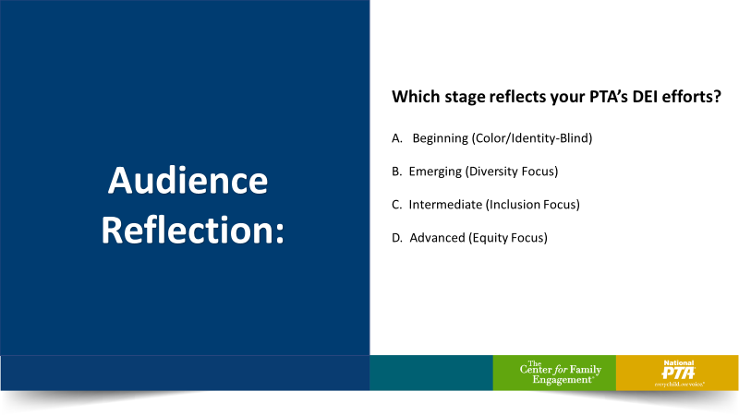  Workshop Response Form:  https://docs.google.com/spreadsheets/d/1ki1Dwnv15cCMaSRgLZlafKxS5aNgInuOjvod7UkD6ns/edit?usp=sharing  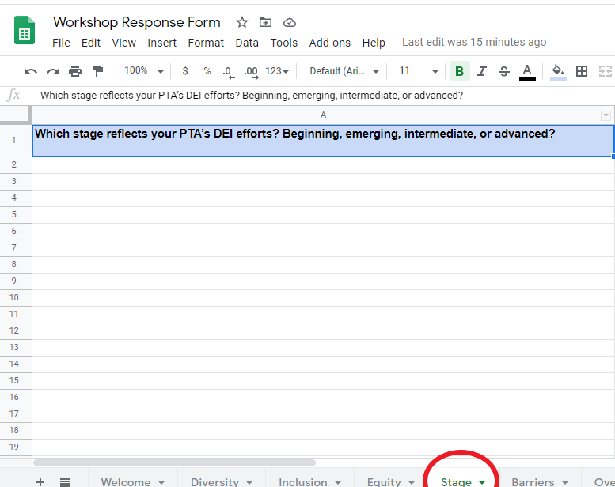
PAUSE FOR: | FACILITATOR GUIDANCE | VISUAL(S)
10 MIN TOTAL  :08 MIN (Focus Groups)  &  :02 MIN (Report Out) | [PAUSE AT 17:23]  [GUIDE DISCUSSION]  - If you have the capabilities, split participants into focus groups (2-7 per group recommended)  - Prompt participants to answer and reflect on, “Which groups are under-represented in your PTA? & What are the barriers to their engagement?”  - If your technology does not allow for you to utilize breakout rooms, participants can brainstorm in the chat box or record their thoughts in the Workshop Response Form’s “Barriers” tab.  - Reconvene as a group and ask participants to report out what they discussed in their groups  [CLICK PLAY] | Slide 15:  BREAKOUT ROOMS/GROUP DISCUSSION  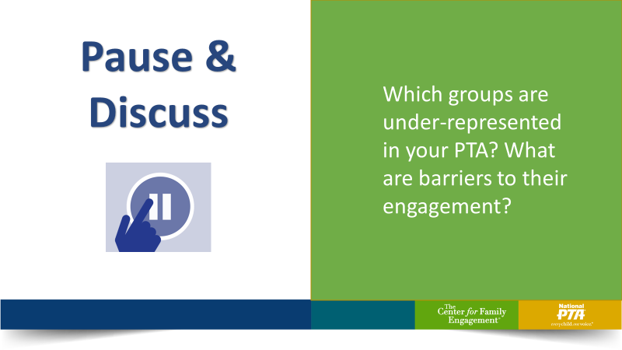  Workshop Response Form:  https://docs.google.com/spreadsheets/d/1ki1Dwnv15cCMaSRgLZlafKxS5aNgInuOjvod7UkD6ns/edit?usp=sharing  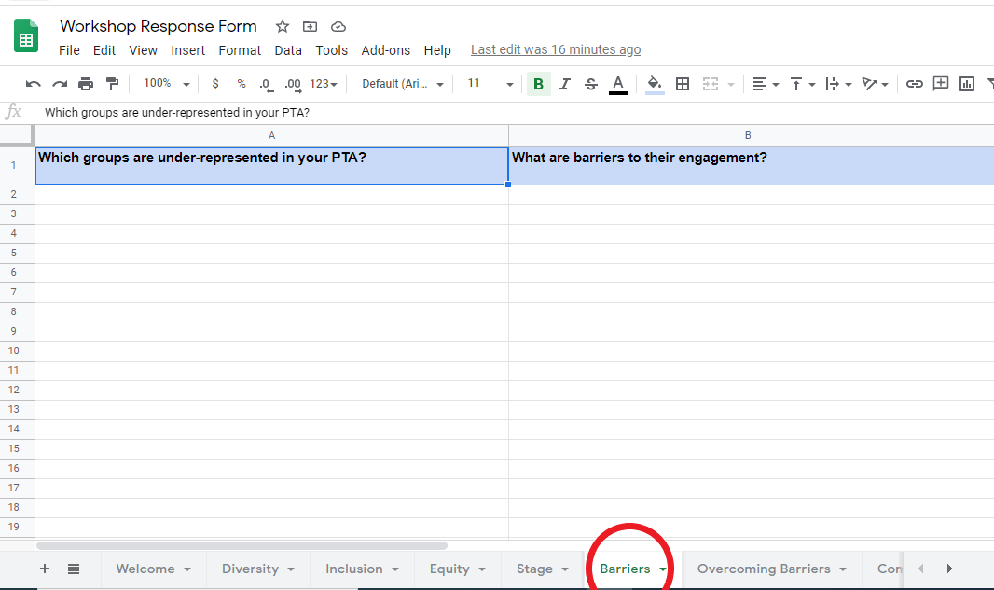
PAUSE FOR: | FACILITATOR GUIDANCE | VISUAL(S)
:02 MIN | [PAUSE AT 28:26]  [GUIDE DISCUSSION]  -Prompt participants to answer the poll question, “How would you refine or revolutionize PTA’s governance structures to advance diversity, equity and inclusion? (Answer in chat or in the Workshop Response Form’s “Overcoming Barriers” tab)  - If participants are using a chat box, read some of the feedback out loud as it comes in  [CLICK PLAY] | Slide 24: OVERCOMING STRUCTURAL  BARRIERS  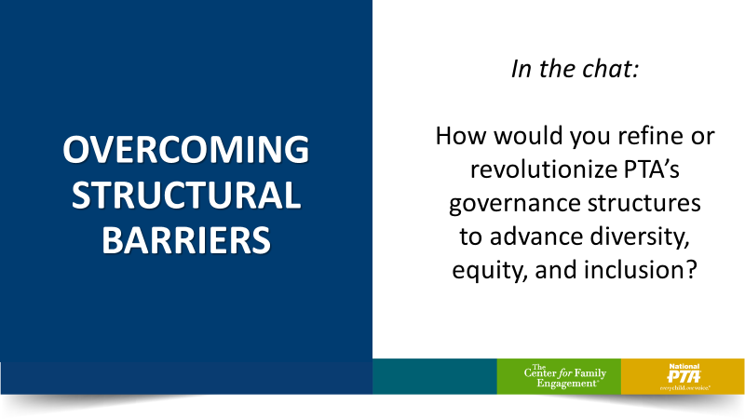  Workshop Response Form:  https://docs.google.com/spreadsheets/d/1ki1Dwnv15cCMaSRgLZlafKxS5aNgInuOjvod7UkD6ns/edit?usp=sharing  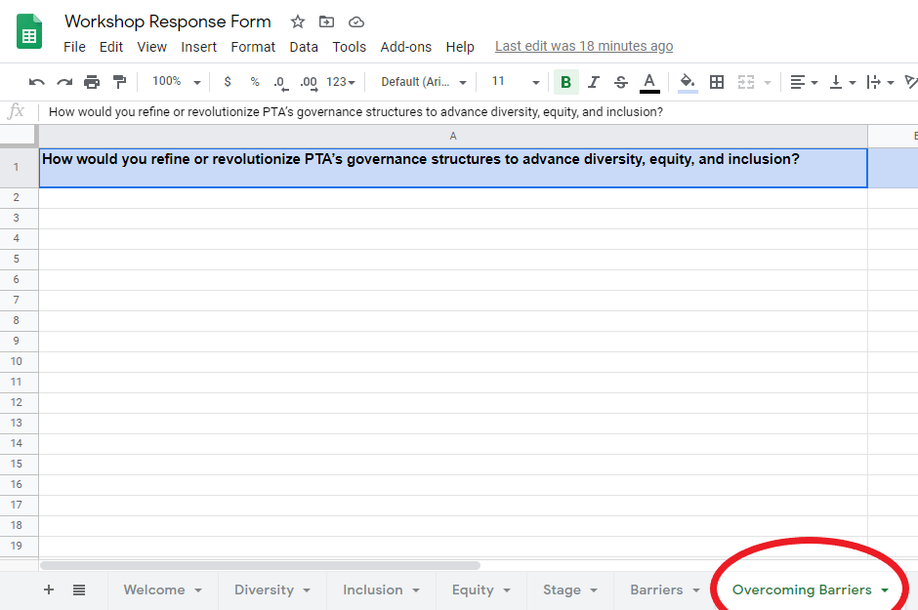

PAUSE FOR: | FACILITATOR GUIDANCE | VISUAL(S)
:02 MIN | [PAUSE AT 36:56]  [GUIDE DISCUSSION]  -Prompt participants to answer, “What is one ting you will start, stop, or change to advance diversity, equity and inclusion in your PTA?” (Answer in chat or in the Workshop Response Form’s “Commitment” tab)  - If participants are using a chat box, read some of the feedback out loud as it comes in  [CLICK PLAY] | Slide 29: YOUR COMMITMENT  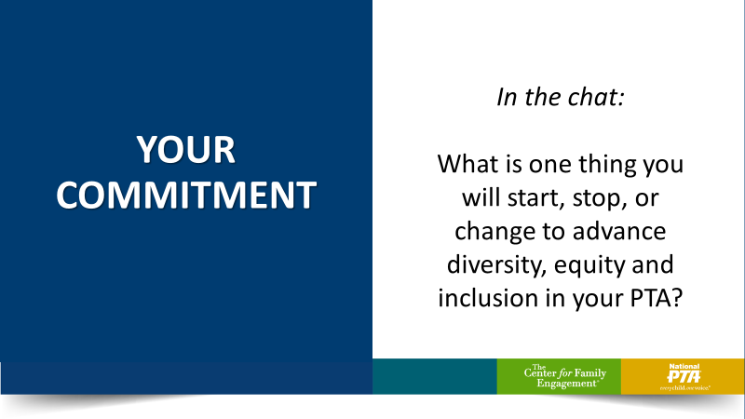  Workshop Response Form:  https://docs.google.com/spreadsheets/d/1ki1Dwnv15cCMaSRgLZlafKxS5aNgInuOjvod7UkD6ns/edit?usp=sharing  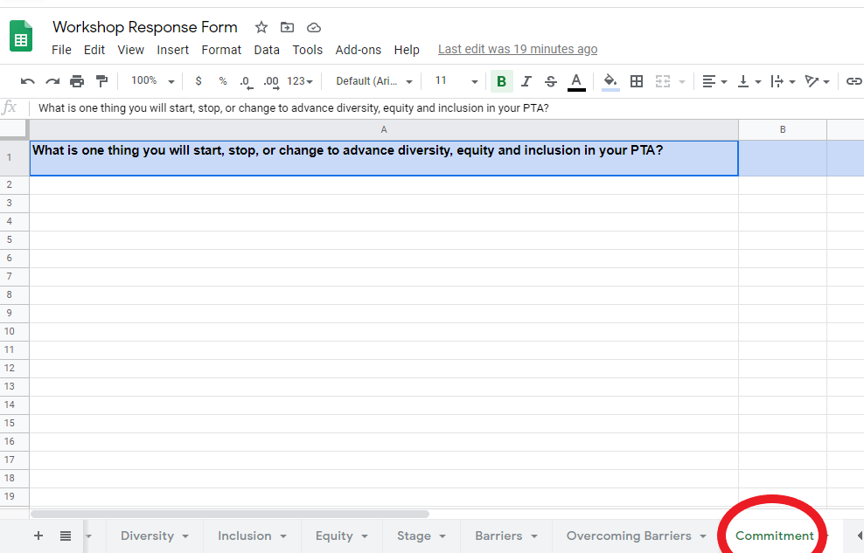

PAUSE FOR: | RECOMMENDED TALKING POINTS | VISUAL(S)
:00 Min | [END OF PRESENTATION]  -Prompt participants to provide feedback on the workshop by completing this form: https://forms.gle/RgipEx3DuK8EMLAk8 (post link in the chat)  -Closing remarks from facilitator | Slide 32:

